Assessment Schedule – 2013

Music: Demonstrate knowledge of conventions in a range of music scores (91276)

Evidence Statement
Question | Achievement | Achievement with Merit | Achievement with Excellence
ONE | Score Extract A: Menuetto and Trio
(a) (i) | Gives the English meaning of “Allegretto”, eg:  - moderately fast / lively.
(ii) | Identifies OR simply describes the metre:  - triple / three beats per bar. | Identifies AND describes the metre:  - simple triple, with three crotchet beats per bar.
(iii) | Names the clef:  - alto clef. | Explains the reason for its use, eg:  - to avoid leger lines.
(b) (i) | Names the articulation mark, AND explains its meaning, eg:  - slur  - play the slurred notes smoothly.
(ii) |  | Describes the instrumental technique used to perform the two notes, eg:  - the violinist would play the two notes in a single bow / without changing bow direction.
(iii) |  |  | Explains the effect of this instrumental technique on the emphasis of the notes, eg:  - the first note of the pair would have more emphasis.
(c) (i) | Identifies the key of BOTH passages: | Gives ONE piece of evidence to justify the identification of EACH key, eg:
 | - A – D major | - key signature of two sharps, (and no A# to indicate B minor)  - perfect cadence over bars 39–40  - passage ends with a D major scale
 | - B – D minor | - key signature of one flat, and C# / raised leading note  - perfect cadence over bars 65–66.
(ii) |  |  | Explains the relationship between the two keys, eg:  - tonic / parallel major and minor keys  - they have the same tonic note.

Question One (cont’d)
Question | Achievement | Achievement with Merit | Achievement with Excellence
(d)  (i) (ii) (iii) | Identifies the form of the Menuetto:  - binary (do not accept “AB form”). | Describes the sections of the Menuetto, with bar numbers:  - A – bar 1 – bar 8 (beat 2)  - B – bar 8 (beat 3) – bar 42 (beat 2) | Gives TWO pieces of evidence to justify the identification of the form, eg:  - the two sections each have similar material  - section A ends in the dominant key / A major / does not end in the tonic key  - section B opens in the dominant key, and ends in the tonic key / D major.  - section B is longer than section A.
(e)  (i) (ii) (iii) | Identifies the form of the entire piece:  - (extended) ternary form  - minuet and trio. | Describes the sections of the piece, with bar numbers:  - A – Menuetto – bars 1–42  - B – Trio – bars 42–66  - A – Menuetto – bars 1–42 | Gives TWO pieces of evidence to support the identification, eg:  - the B / Trio section contrasts, as it is in a different key (tonic minor)  - the B section contrasts as it has a different theme  - the opening and closing A / Menuetto sections are the same.
(f) | Attempts to make a piano reduction, including:  - the key signature and time signature  - accurate transcription of pitch and rhythm for ONE complete bar. | Makes a partially accurate piano reduction, including:  - the key signature and time signature  - accurate rhythm and pitch  - correct alignment of notes and rests. | Makes an accurate piano reduction, including no more than ONE error in:  - the key signature, time signature, and tempo marking  - ALL performance markings  - idiomatic distribution of material between left- and right-hand parts (chords in LH; melody in RH).
 | 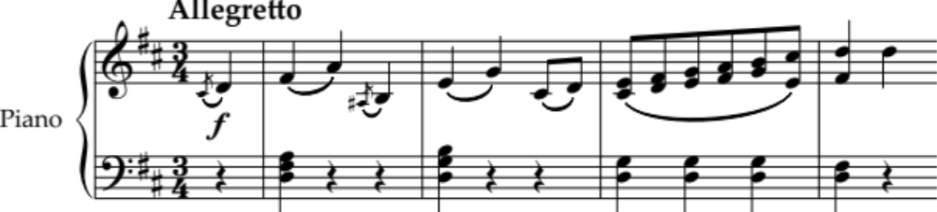

N1 | N2 | A3 | A4 | M5 | M6 | E7 | E8
ONE piece of evidence at Achievement level. | TWO pieces of evidence at Achievement level. | THREE (of eight) pieces of evidence at Achievement level. | FOUR (of eight) pieces of evidence at Achievement level. | TWO (of seven) pieces of evidence at Merit level. | THREE (of seven) pieces of evidence at Merit level. | TWO (of five) pieces of evidence at Excellence level. | THREE (of five) pieces of evidence at Excellence level.
N0= No response; no relevant evidence.

Question | Achievement | Achievement with Merit | Achievement with Excellence
TWO | Score Extract B: “Die Post”
(a) (i) | Identifies the texture:  - homophonic. | Describes the texture, eg:  - a melody accompanied by (broken) chords.
(ii) |  | Describes the metre AND notates a 1-beat note:  - compound duple  
(iii) | Identifies the compositional device:  - arpeggio. |  | Explains how the melody of the introduction imitates a horn, eg:  - the melody is made up of arpeggios of a single chord; the (natural) horn mainly plays the notes of the harmonic series, which form an arpeggio.
(b) (i) (ii) |  | Explains the reason for ONE of the two notational elements, eg:  - bracketed quaver (bar 9) – indicates that this note is not sung in verse 2 / is sung only in verse 1 (on the word “Von”)  - dotted slur (bar 13) – indicates that a single syllable (“lie-“) is sung over two notes in verse 2, but is not required in verse 1 where there is a syllable to each note (“dass es”).
(c) |  |  | Accurately transcribes the vocal line and German lyrics for BOTH verses:  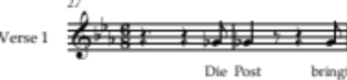  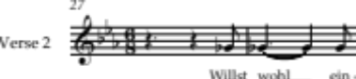
(d) (i) | Identifies the quantity only of FOUR (of 5) intervals. | Fully describes FOUR (of 5) intervals.
- Perfect 4th
- Minor 3rd
- Minor 2nd
- Major 2nd
- Diminished 5th
(ii) |  |  | Describes the range of the vocal part:  - perfect 11th /  compound perfect 4th.

Question Two (cont’d)
Question | Achievement | Achievement with Merit | Achievement with Excellence
(e) | Attempts to write a perfect cadence, including:  - roman numerals: V and I  - bass notes: Bb and Eb | Writes a partially accurate perfect cadence, with no more than TWO of the following incorrect:  - stepwise movement from leading note to tonic  - RH chords complete (three notes in each)  - smooth voice leading  - rhythm of bass and added RH notes matches the notes provided, ie:   | Writes an accurate perfect cadence, as specified:  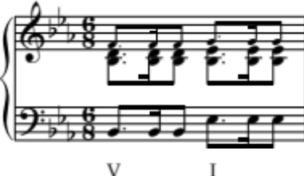

N1 | N2 | A3 | A4 | M5 | M6 | E7 | E8
ONE piece of evidence at Achievement level. | TWO pieces of evidence at Achievement level. | THREE (of four) pieces of evidence at Achievement level. | FOUR (of four) pieces of evidence at Achievement level. | TWO (of five) pieces of evidence at Merit level. | THREE (of five) pieces of evidence at Merit level. | TWO (of four) pieces of evidence at Excellence level. | THREE (of four) pieces of evidence at Excellence level.
N0= No response; no relevant evidence.

Question | Achievement | Achievement with Merit | Achievement with Excellence
THREE | Score Extract C: “Mack the Knife”
(a) (i) | Identifies TWO percussion instruments, AND the technique used by each: | Describes BOTH techniques AND gives a bar number for each, eg:
 | - snare drum – rimshot. | - bar 1 – the shaft of the drumstick hits the rim of the drum at the same time as the tip of the stick hits the head  OR accept the description of rim click: the drumstick hits the rim of the drum.
 | - hi-hat – open (and closed). | - bar 25 – the foot releases the (normally closed) pair of cymbals so that when struck, they ring on instead of being damped.
(ii) | Identifies the convention:  - walking bass. | Describes the convention, eg:  - the bass plays four crotchets per bar with mostly stepwise movement.
(b) (i) | Identifies the term implied by the instruction:  - swung rhythm. | Explains the effect of the instruction on the music, eg:  - pairs of written quavers are played unequally, with the first note lengthened and the second shortened, to create a triplet feel.
(ii) |  |  | Notates the rhythm of the bass part in bars 2–3:  
(c) (i) | Names the jazz term equivalent to “motif”:  - riff
(ii) | Identifies the rhythmic device:  - syncopation. | Describes the rhythmic device, eg:  - (anticipating or delaying notes so that the) accents fall on a normally weak beat.
(iii) |  |  | Explains TWO different ways that syncopation is used in the horn section in bars 29–31, eg:  - bar 29 – a quaver is followed by a dotted crotchet, making an accent fall halfway through beat 1  - bar 30 – a quaver rest occurs on beat 1, making an accent fall halfway through beat 1  - bar 30 – an off-beat quaver (beat 2) is tied to a note on a strong beat (beat 3).

Question Three cont’d
Question | Achievement | Achievement with Merit | Achievement with Excellence
(d) (i) |  | Names the compositional device:  - augmentation  AND EITHER  Describes the compositional device, eg:  - the notes in bar 33 are twice as long as the notes in bar 25 | Names the compositional device:  - augmentation  AND  Describes the compositional device, eg:  - the notes in bar 33 are twice as long as the notes in bar 25
(ii) |  | OR  Notates the written rhythm of the horn parts in bars 32–33, and includes the starting bar number, eg:  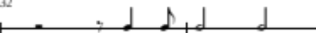 | AND  Notates the written rhythm of the horn parts in bars 32–33, and includes the starting bar number, eg:
(e) (i) | Identifies an appropriate instrument capable of playing the chords, eg:  - guitar
(ii) |  | Notates TWO chords accurately:  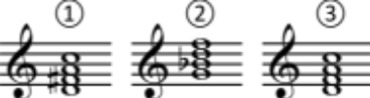
(f) | Transposes the passage by an interval other than a major 2nd, including:  - all pitches correct relative to the original passage, with allowance for ONE error. | Transposes the passage up a major 2nd into A major, including:  - the key signature  - all pitches correct relative to the original passage, with allowance for ONE error. | Transcribes the passage accurately into concert pitch of F major, including:  - the key signature  - all pitches and accidentals correct, with allowance for ONE error  - all performance directions.
 | 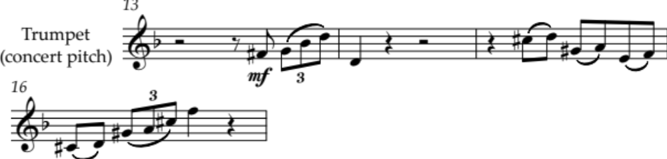

N1 | N2 | A3 | A4 | M5 | M6 | E7 | E8
ONE piece of evidence at Achievement level. | TWO pieces of evidence at Achievement level. | THREE (of seven) pieces of evidence at Achievement level. | FOUR (of seven) pieces of evidence at Achievement level. | FOUR (of six) pieces of evidence at Merit level. | FIVE (of six) pieces of evidence at Merit level. | TWO (of four) pieces of evidence at Excellence level. | THREE (of four) pieces of evidence at Excellence level.
N0= No response; no relevant evidence.

Judgement Statement
 | Not Achieved | Achievement | Achievement  with Merit | Achievement  with Excellence
Score range | 0 – 8 | 9 – 13 | 14 – 19 | 20 – 24

